**AWS data pipeline project 1**

  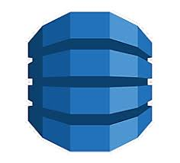







**AWS Eventbridge** : using this the lambda-1 is triggered every two minutes

**AWS lambda-1** : in lambda-1 we developed the code for data generations, in every two minutes this code is triggered and data is send to lambda-2, for every data a random key is associated to avoid sending same data again.

**AWS lambda-2** : in lambda-2 we developed the code to send data to S3 so in every two minutes lambda-1 is triggered and lambda-2 receive the data, finally reaches that data to S3 bucket

**AWS Glue** : using glue we fetch the data from S3 and process it to get some

insights.

**AWS DynamoDB** : at last the transformed data is stored in the database